Assignment 3

Gavyn Gallagher

MSDS 460

# Question 1

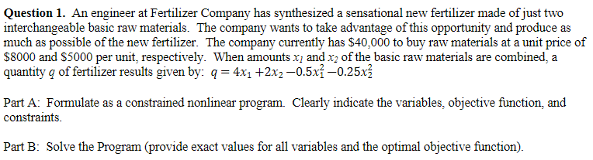

## Part A:

Variables:

* X1
* X2

## Objective:

* Maximize z = 4*X1 + 2*X2 -0.5X^2 - 0.25*X2^2

Constraints:

* 8,000*X1 + 5,000*X2 <= 40,000
* X1, X2 >=0

## 

## 

## 

## Part B:

**Answer:**

Objective: 11.36842

X1 = 3.157895

X2 = 2.947368

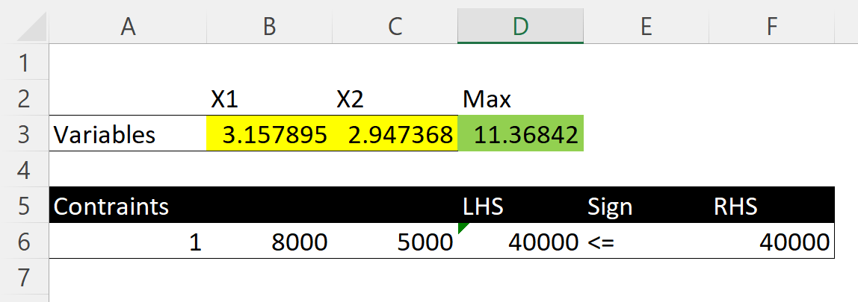

Excel Answers of Problem 1

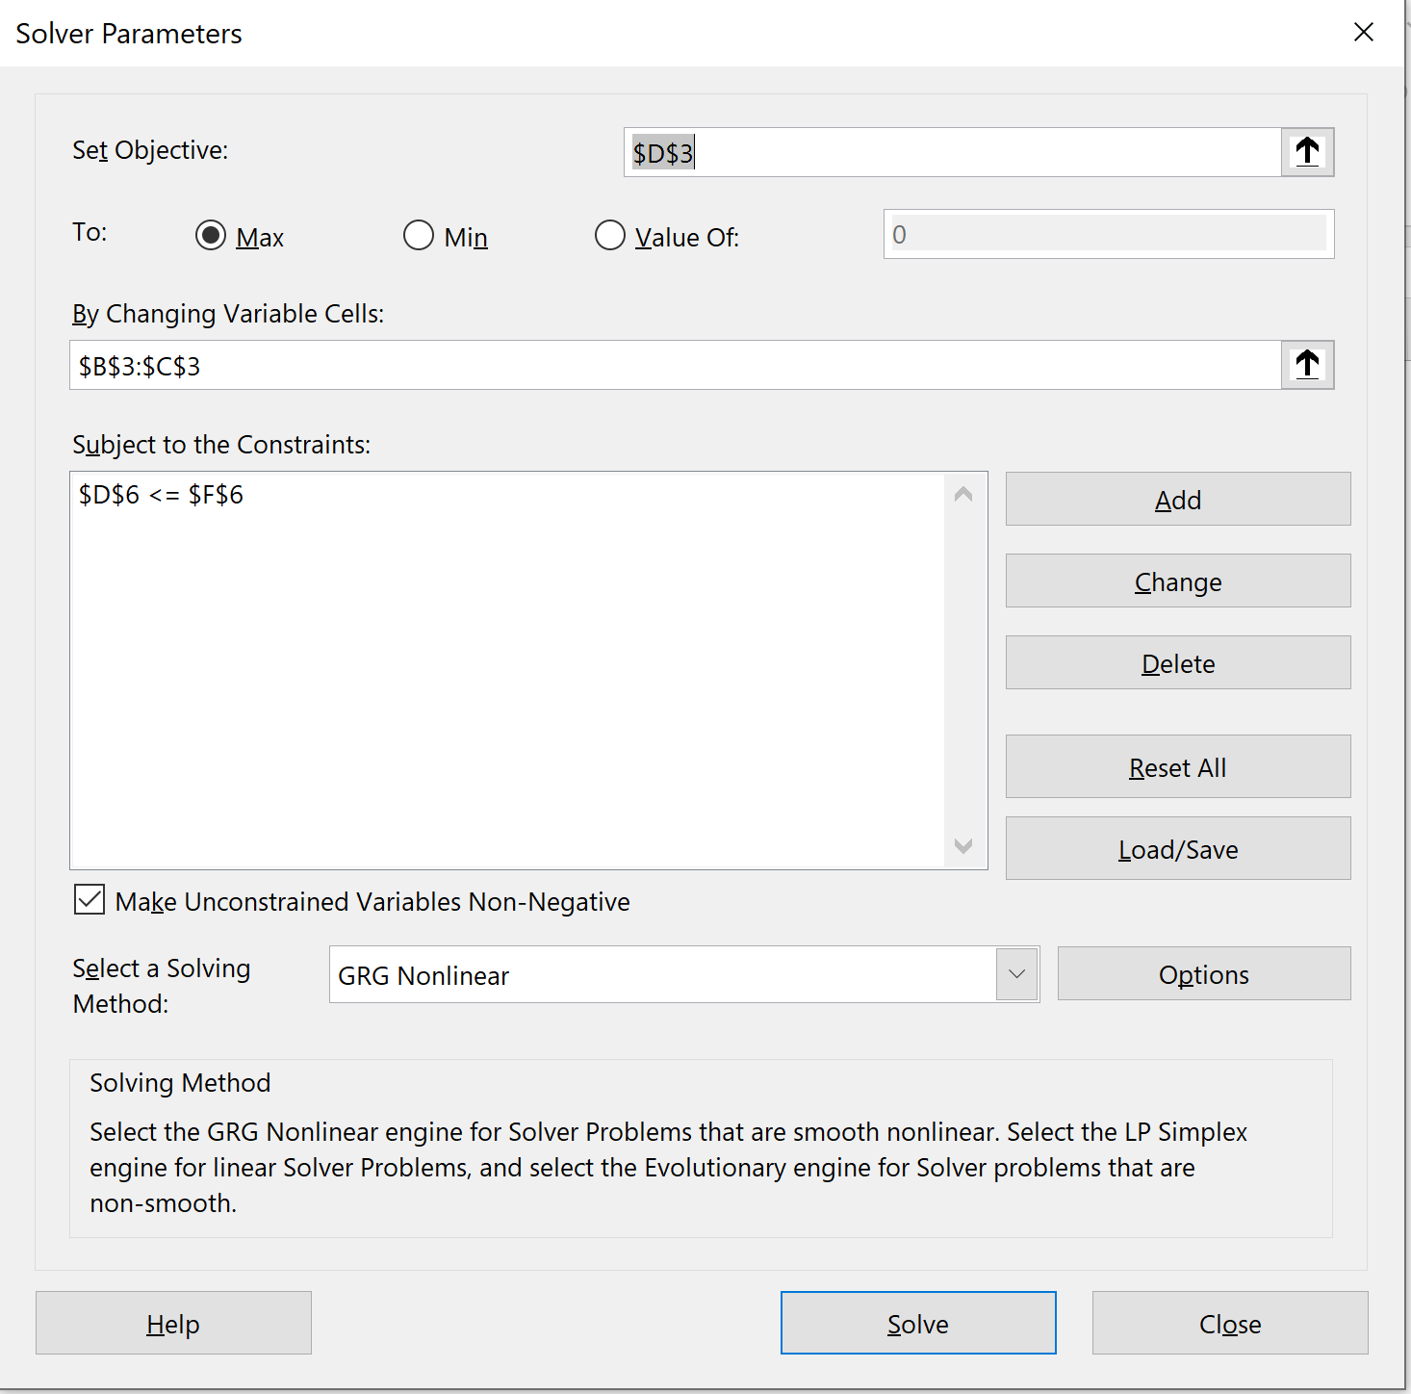

Excel Solver of Problem 1

Question 2

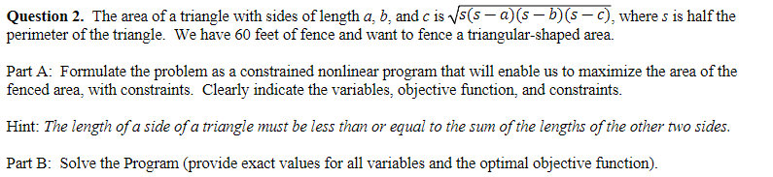

Part A:

Variables:

* SideA
* SideB
* SideC
* s

## Objective:

* Maximize z =
* Note s = (SideA + SideB +SideC) / 2

Constraints:

* SideA <= SideB + SideC
* SideB <= SideA + SideC
* SideC <= SideA + SideB
* SideA + SideB + SideC <= 60

Part B:

**Answer:**

* Objective: Area= 173.2051 ft^2
* SideA: 20
* SideB: 20
* SideC: 20
* s : 30

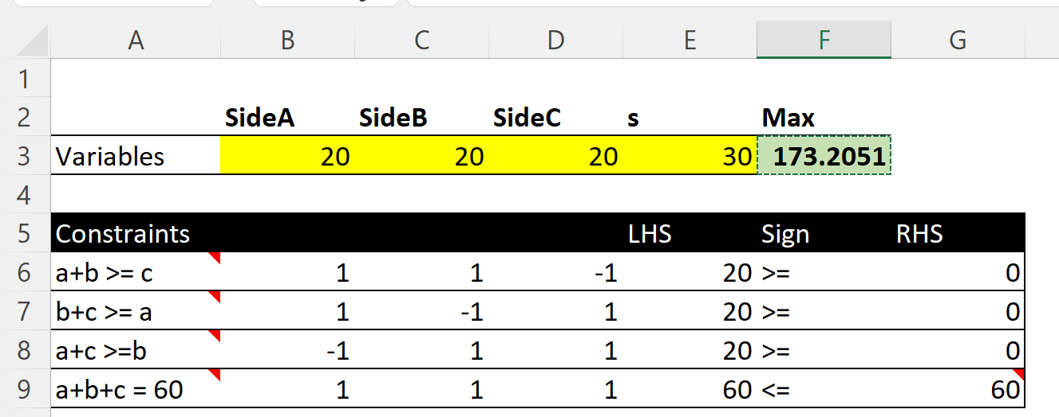

Excel answers of Problem 2

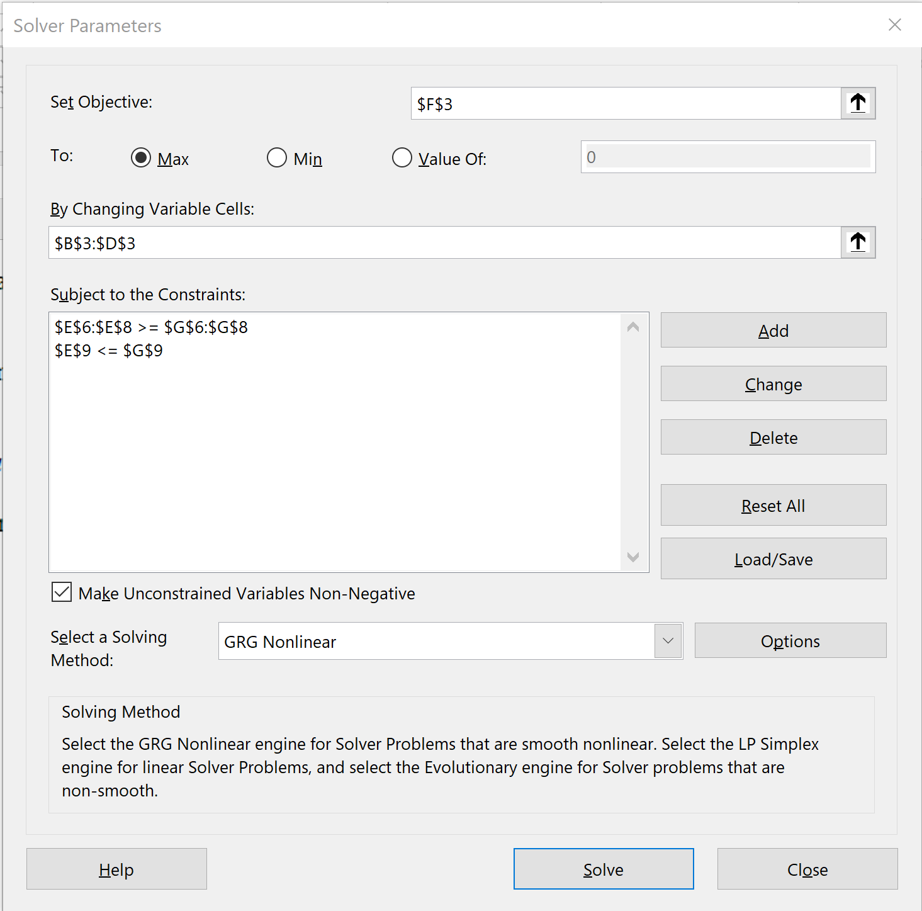

Excel Solver of Problem 2

# 

# **Question 3.**

The Tiny Toy Company makes three types of new toys: the tiny tank, the tiny truck, and the tiny turtle. Plastic used in one unit of each is **1.5, 2.0 and 1.0** pounds, respectively. Rubber for one unit of each toy is **0.5, 0.5, and 1.0** pounds, respectively. Also, each tank uses **0.3** pounds of metal and the truck uses **0.6** pounds of **metal** during production. The average weekly availability for plastic is **16,000** pounds, **9,000** pounds of metal, and **5,000** pounds of rubber. It takes **2** hours of labor to make 1 tank, **2** hours for1 truck, and **1** hour for a turtle. The company allows no more than **40** hours a week for production (priority #1). Finally, the cost of manufacturing one tank is $**7**, 1 truck is $**5** and 1 turtle is $**4**; a target budget of $**164,000** is initially used as a guideline for the company to follow.

a) Minimize over-utilization of the weekly available supply of materials used in making the toys and place twice as much emphasis on the plastic (priority #2)

b) Minimize the under and over-utilization of the budget. Maximize available labor hour usage (priority #3).

Formulate the above decision problem as a single linear goal program. Clearly identify your achievement vector (i.e., hierarchy of priority levels for the goals). Do not solve.

Table of Problem:

|  | **Tank** | **Truck** | **Turtle** | **Available** |
| --- | --- | --- | --- | --- |
| **Plastic** | 1.5 | 2.0 | 1.0 | 16,000 |
| **Rubber** | 0.5 | 0.5 | 1.0 | 5,000 |
| **Metal** | 0.3 | 0.6 |  | 9,000 |
| **Labor** | 2.0 | 2.0 | 1.0 | 40 |
| **Cost** | 7.0 | 5.0 | 4.0 | 164,000 |

Variables:

* Tank
* Truck
* Turtle

Objective:

* Maximize Z= Tank + Truck + Turtle

Constraints:

* 2.0*Tank + 2.0*Truck + 1.0*Turtle <= 40 #(Prioirty 1) Labor
* 1.5*Tank + 2.0*Truck + 1.0*Turtle <= 16,000 # (Priority 3) Plastic 2x
* 0.5*Tank + 0.5*Truck + 1*Turtle <= 5,000 # (Prioirity 3) Rubber
* 0.3*Tank + 0.6*Truck >= 9,000 # (Prioirity 3) Metal
* 7*Tank + 5*Truck + 4*Turtle <=164000 # (Priority 2) Minimize Overutilization
* 7*Tank + 5*Truck + 4*Turtle >=164000 # (Priority 2) Minimize underrutilization
* Tank, Truck, Turtle >= 0

Goal Programming Form:

* 2.0*Tank + 2.0*Truck + 1.0*Turtle + η1 - ρ1 = 40 #(Priority 1) Labor
* 1.5*Tank + 2.0*Truck + 1.0*Turtle + η2 - ρ2 = 16,000 #(Prioirity 3)
* 0.5*Tank + 0.5*Truck + 1*Turtle + η3 - ρ3 = 5,000 # (Priority 3)
* 0.3*Tank + 0.6*Truck + η4 - ρ4 = 9,000 # (Priority 3)
* 7*Tank + 5*Truck + 4*Turtle + η5 - ρ5 =164,000 # (Priority 2)
* 7*Tank + 5*Truck + 4*Turtle + η6 - ρ6 =164,000 # (Priority 2)
* Tank, Truck, Turtle >=0 aηd ηi, ρi >= 0 for all i

Achievement Vector:

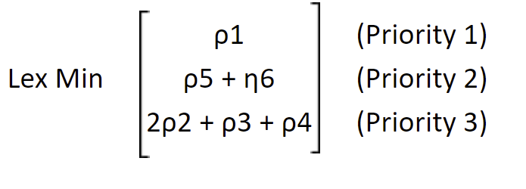

# Question 4

**Question 4.** XYZ Company is planning an advertising campaign for its new product. The media considered are television and radio. Rated exposures per thousand dollars of advertising expenditure are **10,000** for TV and **7,500** for radio. Management has agreed that the campaign cannot be judged successful if total exposures are under **750,000**. The campaign would be viewed as superbly successful if **1 million** exposures occurred. In addition, the company has realized that the two most important audiences for its product are persons 18 to 21 years of age and persons 25 to 30 years of age. The following table estimates the number of individuals in the two age groups expected to be exposed to advertisements per **$ 1,000** of expenditures:

| Exposures per $1000  Age Television Radio |
| --- |
| 18‑21 2,500 3,000  25‑30 3,000 1,500 |

Management has rank-ordered five goals it wishes to achieve, arranged from highest to lowest priorities.

a) Achieve total exposures of at least 750,000 persons.

b) Avoid expenditures of more than $100,000.

c) Avoid expenditures of more than $70,000 for television advertisements.

d) Achieve at least 1 million total exposures.

e) Reach at least 250,000 persons in each of the two age groups, 18‑21 and 25‑30 years. In addition, management realizes and wishes to account for the fact that the purchasing power of the 25‑30 age group is twice that of the 18‑21 age group.

Formulate the above decision problem as a single linear goal program. Clearly identify your achievement vector (i.e., hierarchy of priority levels for the goals). **Do not solve**.

Variables:

* TV
* Radio

Objective:

* Minimize Z= 1,000*TV + 1,000*Radio #Spend the least amount possible

I interpreted this problem as the goal was to minimize cost while satisfying the exposure constraint.

Constraints:

* 10,000*TV + 7,500*Radio >= 750,000 # (Priority A)
* 1,000*TV + 1,000*radio <= 100,000 # (Priority B)
* 1,000*TV <= 70,000 # (Priority C)
* 10,000*TV + 7,500*Radio >= 1,000,000 # (Priority D)
* 2,500*TV + 3,000*Radio >= 250,000 # age group 18-21 # (Priority E)
* 3,000*TV + 1,500*Radio >= 250,000 # age group 25-30 # (Priority E)
* TV, Radio >= 0

Goal Programming Form:

* 10,000*TV + 7,000*Radio + η1 - ρ1 =750,000 # (Priority A)
* 1,000*TV + 1,000*Radio + η1 - ρ1 =10,000 # (Priority B)
* 1,000*TV + η3 - ρ3 =70,000 # (Priority C)
* 10,000*TV + 7,500*Radio + η4 - ρ4 =100,000 # (Priority D)
* 2,500*TV + 3,000*Radio + η5 - ρ5 =250,000 # (Priority E)
* 3,000*TV + 1,500*Radio + η6 - ρ6 =250,000 # (Priority E)
* TV, Radio >= 0 aηd ηi, ρi >= 0 for all i # non-negativity

Achievement Vector:

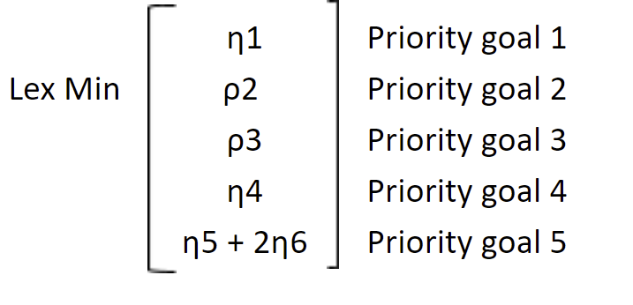

# Question 5

**Question 5.** A large food chain owns a number of pharmacies that operate in a variety of settings. Some are situated in small towns and are open for only **8** hours a day, **5** days per week. Others are located in shopping malls and are open for longer hours. The analysts on the corporate staff would like to develop a model to show how a store’s revenues depend on the number of hours that it is open. They have collected the following information from a sample of stores.

| **Hours of Operation** | **Average Revenue ($)** |
| --- | --- |
| 40 | 5958 |
| 44 | 6662 |
| 48 | 6004 |
| 48 | 6011 |
| 60 | 7250 |
| 70 | 8632 |
| 72 | 6964 |
| 90 | 11097 |
| 100 | 9107 |
| 168 | 11498 |

a) Use a linear function (e.g., y = ax + b; where a and b are parameters to optimize) to represent the relationship between revenue and operating hours and find the values of the parameters using the nonlinear solver that provide the **best fit** to the given data. What revenue does your model predict for 120 hours?

b) Suggest a two-parameter nonlinear model (e.g., y = axb; where a and b are parameters to optimize) for the same relationship and find the parameters using the Nonlinear Solver that provide the **best fit**. What revenue does your model predict for 120 hours? Which if the models in (a) and (b) do you prefer and why?

Your solutions for (a) and (b) should contain a detailed spreadsheet model (where the decision variables, parameters, objective function and constraints are identified and explained), as well as answers to the questions posed. You may use Microsoft Excel, Python, or R to solve.

A)

With y = a*x + b

At 120 hours, Revenue = $10,083.54

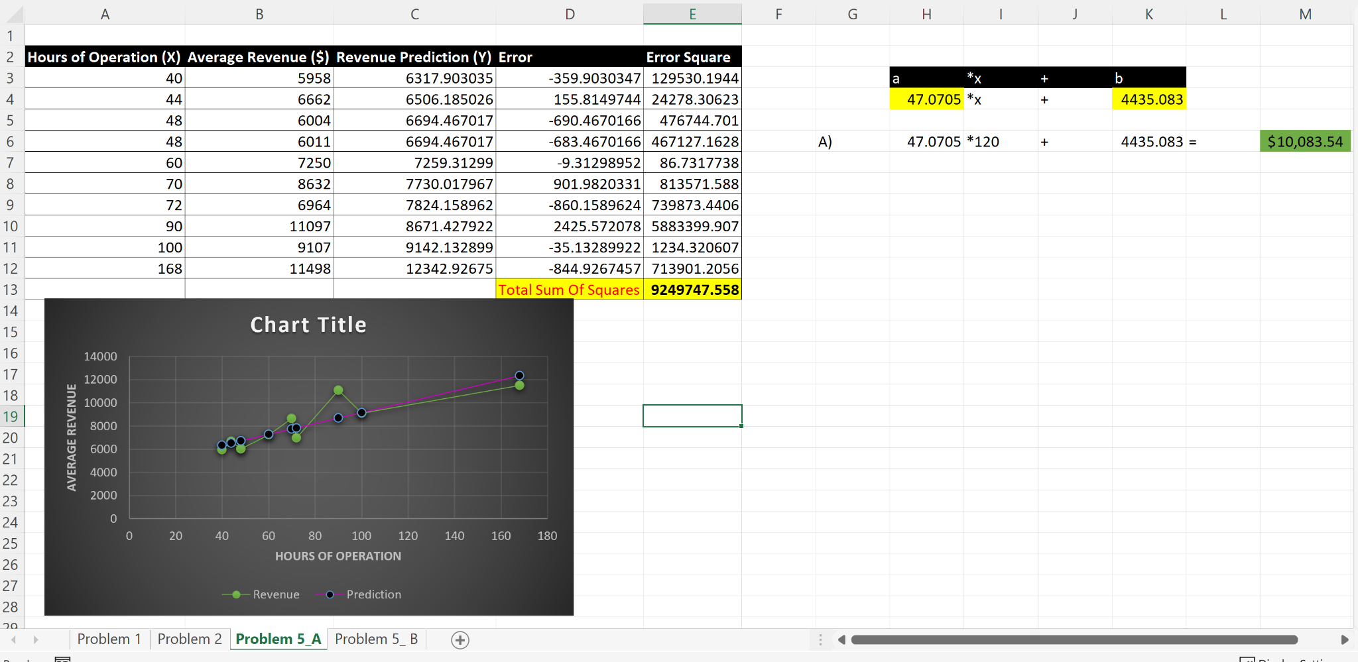

Excel of Problem 5 Part A

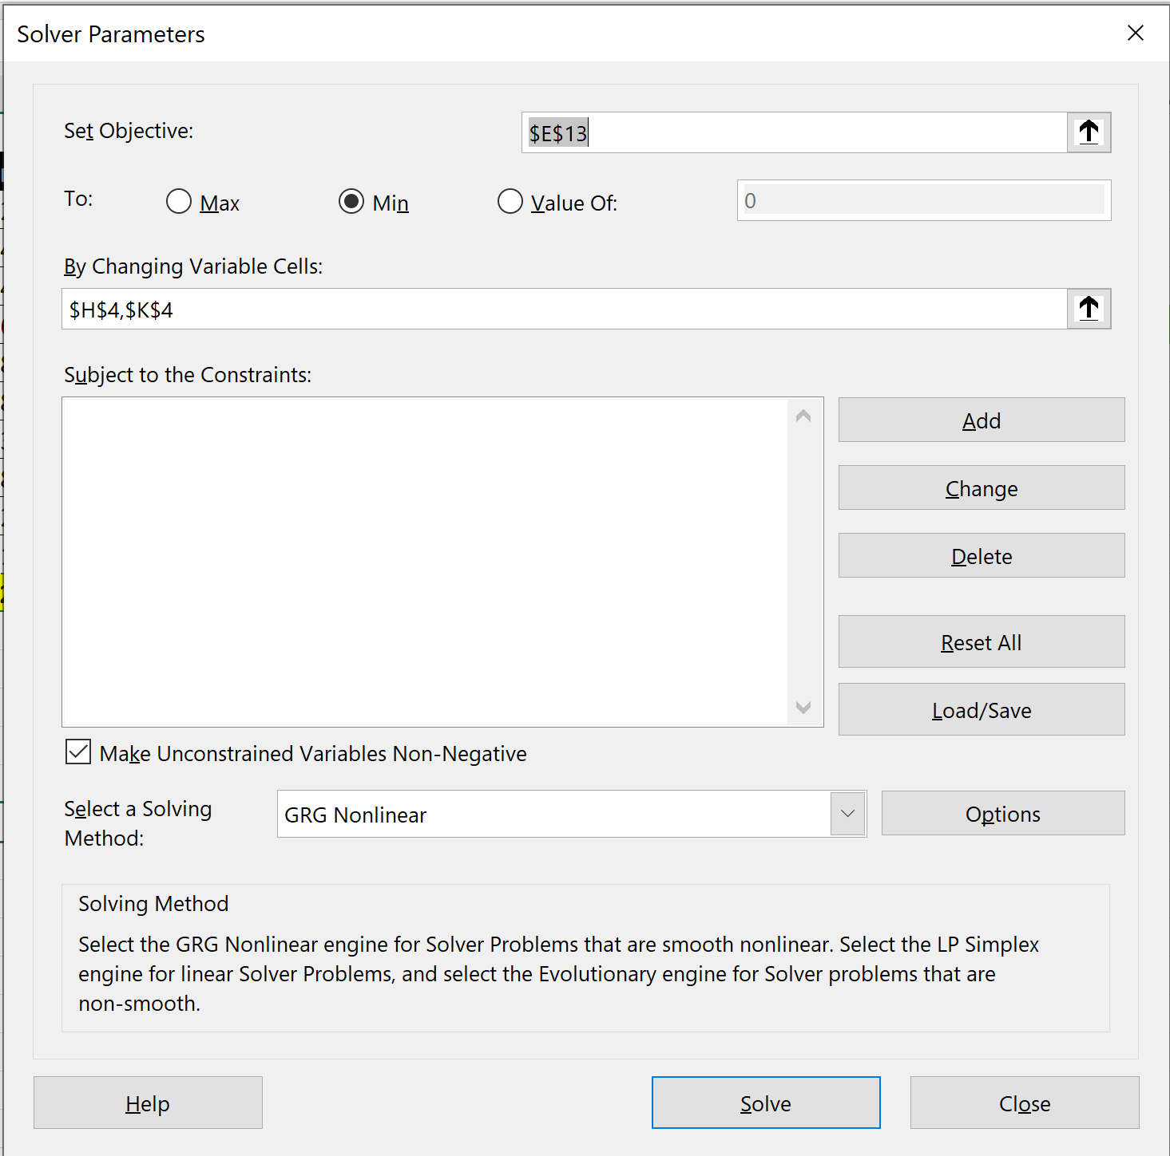

Excel Solver of Problem 5 Part A

B)

I used as a nonlinear formula y = a * (x^2) + 2

When x = 120 hours, Revenue = $9,113.72

Since my Part A = $10,083.54 and is higher than Part B = $9,113.72, I would prefer Part A.

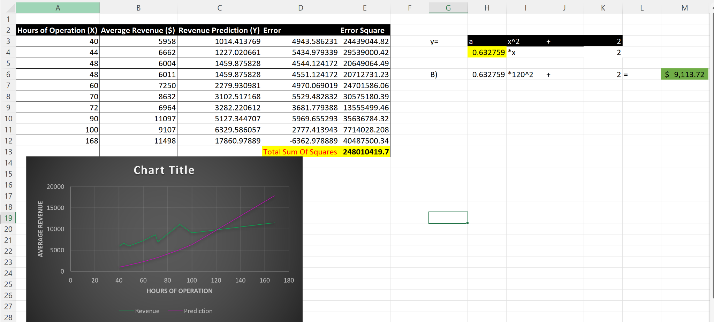

Excel of Problem 5 part B, notice that the purple line is curved

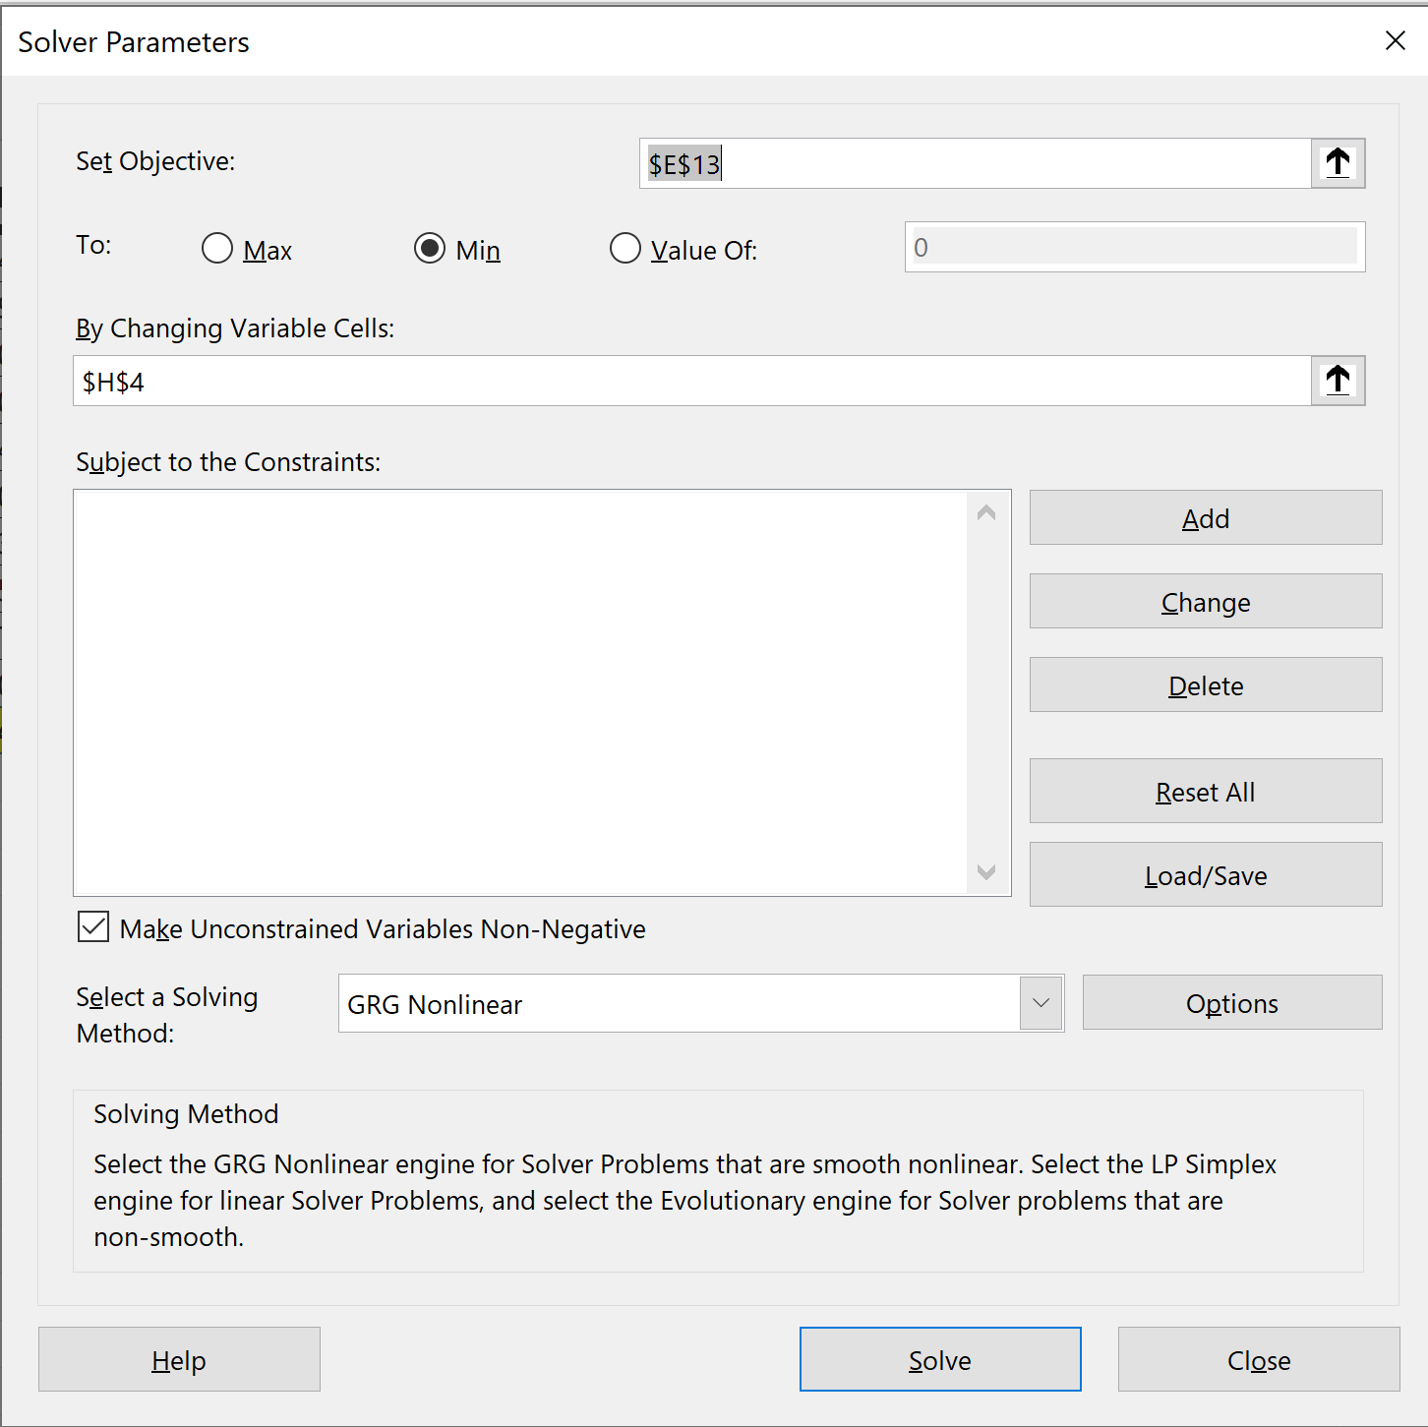

Solver for Problem 5 Part